**Corrección primer parcial**

**Diego Mateus Cruz**

2. Sean f(x) = tan(πx) y g(x) = sin(πx) dos funciones de valor real.

a) Utilice la siguiente formula recursiva con E = 10−9 para determinar al menos dos primeras raíces reales positivas, que representan la intersección entre las funciones.

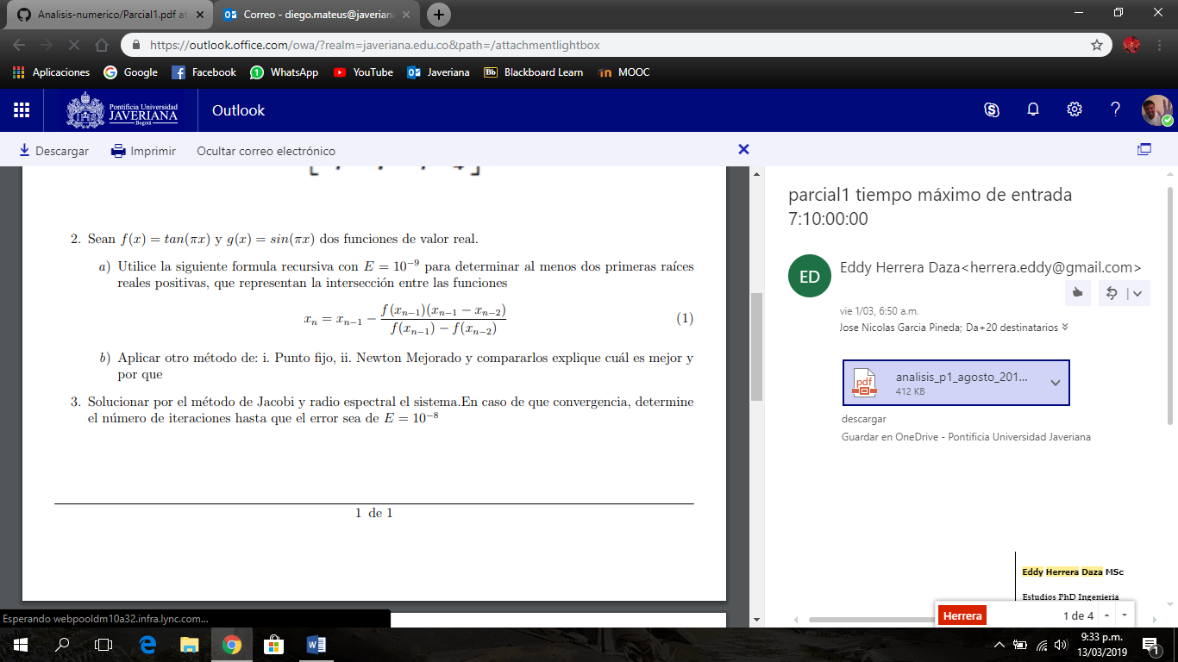

b) Aplicar otro método de: i. Punto fijo, ii. Newton Mejorado y compararlos explique cuál es mejor y por que

**Desarrollo**

**a)**

----------------------------------------------------------

Xn Xn-1 Error est.

----------------------------------------------------------

9.99488951793221 -0.0160564325381598 -0.089889517932206

9.99490319756423 -0.0160134456567585 -1.36796320280057e-05

9.99659750708273 -0.0106896538891738 -0.00169430951849177

9.99731501638882 -0.00843532485037586 -0.000717509306091916

9.99800824000296 -0.00625738024134757 -0.00069322361413902

9.99848641586739 -0.00475510063028964 -0.000478175864429785

9.99886036141079 -0.00358029551751745 -0.000373945543403815

9.99913886112756 -0.00270535415545148 -0.000278499716772934

9.99935019243008 -0.0020414335237767 -0.000211331302511938

9.99950940285184 -0.00154125761693073 -0.000159210421767504

9.99962967997074 -0.00116339520826966 -0.000120277118901273

9.99972044759789 -0.000878239998551153 -9.07676271492475e-05

9.9997889738845 -0.000662958191284634 -6.8526286611655e-05

9.99984070058279 -0.000500453920613487 -5.17266982844642e-05

9.99987974857432 -0.000377781013476565 -3.90479915297758e-05

9.99990922484044 -0.000285178582140576 -2.9476266119897e-05

9.99993147587151 -0.00021527490199842 -2.2251031066597e-05

9.99994827266223 -0.000162506225748855 -1.67967907277608e-05

9.99996095218912 -0.000122672316410007 -1.26795268872281e-05

9.9999705236797 -9.2602591581859e-05 -9.57149057538789e-06

9.99997774898472 -6.99036262559856e-05 -7.22530502134586e-06

9.99998320320633 -5.27686836453647e-05 -5.45422161100525e-06

9.99998732047772 -3.98338940615695e-05 -4.11727139179896e-06

9.99999042851482 -3.00697075520009e-05 -3.10803709367115e-06

9.99999277470589 -2.26989309035802e-05 -2.34619107459774e-06

9.99999454579773 -1.71348817936829e-05 -1.77109183814591e-06

9.99999588276033 -1.29346899006597e-05 -1.33696260286123e-06

9.99999689202304 -9.76399758710061e-06 -1.00926270891361e-06

9.99999765391135 -7.37045487178376e-06 -7.61888308474248e-07

9.99999822909162 -5.56347275932319e-06 -5.75180271155858e-07

9.99999866334954 -4.19921125552369e-06 -4.34257923679777e-07

9.99999899130646 -3.16890420161433e-06 -3.27956920496695e-07

9.99999923909321 -2.39045917050614e-06 -2.47786749161592e-07

9.99999942657721 -1.80146081641388e-06 -1.87483999559766e-07

9.99999956878298 -1.35470822593554e-06 -1.42205765450565e-07

9.99999967744948 -1.01332234814608e-06 -1.0866650066391e-07

9.99999976173445 -7.48533300568776e-07 -8.42849711383485e-08

9.99999982958759 -5.353663871145e-07 -6.78531368799903e-08

9.99999988943892 -3.47337878795569e-07 -5.98513323045817e-08

9.99999995530946 -1.40399483487058e-07 -6.58705370240497e-08

10.000000095952 3.01441956392861e-07 -1.40642498920258e-07

10.0000003465333 1.08866649617104e-06 -2.50581353025731e-07

10.0000001065801 3.34831361411489e-07 2.39953174910321e-07

10.0000001148935 3.60948684826557e-07 -8.31340222884111e-09

10.0000001444523 4.5381026813836e-07 -2.95587609697476e-08

10.000000136489 4.28792765402264e-07 7.96331911219225e-09

10.0000001376431 4.32418490899878e-07 -1.15410418741875e-09

10.0000001376431 4.32418490899878e-07 0

La raiz en el intervalo es: ( 10.0000 )

Error: 0 con un número de iteraciones 48

> raiz(21.905,22.1,10^-9)

----------------------------------------------------------

Xn Xn-1 Error est.

----------------------------------------------------------

21.9948895179322 -0.0160564325381648 -0.0898895179322023

21.9949031975642 -0.0160134456567671 -1.36796320280279e-05

21.9965975070821 -0.0106896538909909 -0.00169430951791708

21.9973150163885 -0.00843532485133308 -0.000717509306370412

21.9980082400027 -0.0062573802421662 -0.000693223614182591

21.9984864158672 -0.0047551006309093 -0.000478175864493605

21.9988603614106 -0.00358029551798078 -0.00037394554345236

21.9991388611275 -0.00270535415579402 -0.000278499716813346

21.99935019243 -0.00204143352406949 -0.000211331302525679

21.9995094028518 -0.00154125761704944 -0.000159210421822683

21.9996296799707 -0.0011633952083635 -0.000120277118911615

21.9997204475979 -0.000878239998652098 -9.07676271432181e-05

21.9997889738845 -0.000662958191275445 -6.85262866501627e-05

21.9998407005828 -0.000500453920689564 -5.1726698255849e-05

21.9998797485743 -0.000377781013616591 -3.90479915083205e-05

21.9999092248406 -0.000285178581687298 -2.94762663105008e-05

21.9999314758718 -0.000215274901019341 -2.22510312355741e-05

21.9999482726624 -0.00016250622529913 -1.67967905571875e-05

21.9999609521898 -0.000122672314233663 -1.26795274415526e-05

21.9999705236804 -9.26025894232786e-05 -9.57149056806532e-06

21.9999777489863 -6.99036213902374e-05 -7.22530588157543e-06

21.9999832032086 -5.27686763992983e-05 -5.45422236744546e-06

21.999987320482 -3.98338805520689e-05 -4.11727338896122e-06

21.9999904285226 -3.00696830113243e-05 -3.10804060013862e-06

21.9999927747188 -2.26988902477944e-05 -2.34619620524824e-06

21.9999945458197 -1.71348128618489e-05 -1.77110084154406e-06

21.9999958828012 -1.29345614075809e-05 -1.33698156282983e-06

21.9999968920889 -9.76379068207822e-06 -1.00928766344663e-06

21.9999976540307 -7.37007980971753e-06 -7.61941836917343e-07

21.9999982293049 -5.56280256622624e-06 -5.75274214603794e-07

21.9999986637203 -4.19804660639506e-06 -4.34415311833912e-07

21.9999989919535 -3.16687148953085e-06 -3.28233233612266e-07

21.9999992402371 -2.38686547063918e-06 -2.48283627924233e-07

21.9999994285543 -1.79524965474407e-06 -1.88317161878611e-07

21.9999995723189 -1.34359975859363e-06 -1.43764625711909e-07

21.9999996836889 -9.93720500582812e-07 -1.11370026637531e-07

21.9999997730789 -7.12893661466262e-07 -8.93899607832039e-08

21.9999998510925 -4.67806667211214e-07 -7.80136123103735e-08

21.9999999352074 -2.03551972640373e-07 -8.41148816822307e-08

22.0000001022511 3.21231316184078e-07 -1.67043707765519e-07

22.0000006844569 2.15028491809682e-06 -5.82205843118132e-07

22.000000110761 3.47965927153551e-07 5.73695952990841e-07

22.0000001186266 3.72676343977391e-07 -7.86557238788896e-09

22.0000002228017 6.99952228592607e-07 -1.04175145704883e-07

22.0000001637818 5.14535561683461e-07 5.90199558571798e-08

22.0000001757428 5.5211233004705e-07 -1.19610557528117e-08

22.0000001793626 5.63484239683236e-07 -3.61979330720212e-09

22.0000001790077 5.62369355498264e-07 3.5488161429117e-10

La raiz en el intervalo es: ( 22.0000 )

Error: 3.548816e-10 con un número de iteraciones 48

**b)**

Con un x0 = 0.77 el resultado es:> newtonDN(f, 9.905, 1e-10, 100)

---------------------------------------------------------------------------

x_k f(x_k) Error est.

---------------------------------------------------------------------------

9.936177389409139 0.004071579650440 0.031177389409140

9.957306455120179 0.001211909998469 0.021129065711040

9.971494615543461 0.000359809981865 0.014188160423283

9.980983662496923 0.000106705838965 0.009489046953461

9.987318667012438 0.000031629094101 0.006335004515515

9.991544658727861 0.000009373238609 0.004225991715422

9.994362773643862 0.000002777474625 0.002818114916002

9.996241751377960 0.000000822983786 0.001878977734097

9.997494470414230 0.000000243851233 0.001252719036269

9.998329639592860 0.000000072252549 0.000835169178630

9.998886426979356 0.000000021408047 0.000556787386496

9.999257616721625 0.000000006343147 0.000371189742269

9.999505077626363 0.000000001879452 0.000247460904738

9.999670052324086 0.000000000556871 0.000164974697724

9.999780033537466 0.000000000165002 0.000109981213379

9.999853355680653 0.000000000048889 0.000073322143188

9.999902236528511 0.000000000014486 0.000048880847859

9.999934824351438 0.000000000004292 0.000032587822927

9.999956549236197 0.000000000001272 0.000021724884758

9.999971030837740 0.000000000000377 0.000014481601543

9.999980687225587 0.000000000000112 0.000009656387847

9.999987126076535 0.000000000000033 0.000006438850947

9.999991417597414 0.000000000000010 0.000004291520879

9.999994278721054 0.000000000000003 0.000002861123640

9.999996185125948 0.000000000000001 0.000001906404894

9.999997456968250 0.000000000000000 0.000001271842303

9.999998302625555 0.000000000000000 0.000000845657303

9.999998869416693 0.000000000000000 0.000000566791139

9.999999247952408 0.000000000000000 0.000000378535714

9.999999498592407 0.000000000000000 0.000000250640000

9.999999668322136 0.000000000000000 0.000000169729730

9.999999785138463 0.000000000000000 0.000000116816327

9.999999874601878 0.000000000000000 0.000000089463415

9.999999973935211 0.000000000000000 0.000000099333333

10.000001204735211 -0.000000000000000 0.000001230800000

10.000000805285211 -0.000000000000000 0.000000399450000

10.000000539257240 -0.000000000000000 0.000000266027972

10.000000361461964 -0.000000000000000 0.000000177795276

10.000000246830385 -0.000000000000000 0.000000114631579

10.000000179422978 -0.000000000000000 0.000000067407407

10.000000147422977 -0.000000000000000 0.000000032000000

10.000000138212451 -0.000000000000000 0.000000009210526

10.000000137683040 -0.000000000000000 0.000000000529412

10.000000137622434 0.000000000000000 0.000000000060606

---------------------------------------------------------------------------

k = 44 x = 10 f(x) = 5.2939559e-23 Error estimado <= 6.0606061e-11> cat("\n\nCon un x0 = 2.77 el resultado es:")

Con un x0 = 2.77 el resultado es:> newtonDN(f, 21.905, 1e-10, 100)

---------------------------------------------------------------------------

x_k f(x_k) Error est.

---------------------------------------------------------------------------

21.936177389409142 0.004071579650440 0.031177389409140

21.957306442946901 0.001211911038274 0.021129053537758

21.971494606322800 0.000359810331498 0.014188163375899

21.980983655551125 0.000106705955959 0.009489049228326

21.987318657878383 0.000031629162465 0.006335002327260

21.991544650891928 0.000009373264671 0.004225993013546

21.994362769234467 0.000002777481143 0.002818118342538

21.996241746967812 0.000000822986684 0.001878977733344

21.997494472068162 0.000000243850750 0.001252725100351

21.998329639592868 0.000000072252549 0.000835167524704

21.998886423257815 0.000000021408262 0.000556783664947

21.999257615326048 0.000000006343182 0.000371192068232

21.999505075532998 0.000000001879475 0.000247460206950

21.999670049184019 0.000000000556887 0.000164973651021

21.999780031182393 0.000000000165007 0.000109981998373

21.999853353914453 0.000000000048891 0.000073322732060

21.999902236528545 0.000000000014486 0.000048882614092

21.999934824351595 0.000000000004292 0.000032587823049

21.999956547746340 0.000000000001272 0.000021723394746

21.999971033073397 0.000000000000377 0.000014485327057

21.999980690580170 0.000000000000112 0.000009657506773

21.999987127336716 0.000000000000033 0.000006436756546

21.999991419490630 0.000000000000010 0.000004292153914

21.999994278735933 0.000000000000003 0.000002859245302

21.999996185158626 0.000000000000001 0.000001906422692

21.999997457040980 0.000000000000000 0.000001271882353

21.999998302782554 0.000000000000000 0.000000845741573

21.999998867993909 0.000000000000000 0.000000565211356

21.999999246079017 0.000000000000000 0.000000378085106

21.999999500431016 0.000000000000000 0.000000254352000

21.999999674031017 0.000000000000000 0.000000173600000

21.999999799818251 0.000000000000000 0.000000125787234

21.999999918347662 0.000000000000000 0.000000118529412

22.000000225014329 -0.000000000000000 0.000000306666667

22.000000188214329 -0.000000000000000 0.000000036800000

22.000000179776830 -0.000000000000000 0.000000008437500

22.000000178991115 0.000000000000000 0.000000000785714

22.000000179060081 0.000000000000000 0.000000000068966

---------------------------------------------------------------------------

k = 38 x = 22 f(x) = 0 Error estimado <= -6.8965517e-11

Para poder comparar que método es mejor, se tiene que poner raíces muy grandes, ya que cuando son muy pequeñas están tienen el mismo numero de iteraciones, por lo cual no se puede deducir nada.

En el algoritmo del numeral a tiene que hacer un total de 48 iteraciones para poder encontrar la raíz mientras tanto con el método de Newton solo se realizaron 38, por ende, el método de Newton es mucho mejor.